1.create a pod for nginx with the pv and pvc:

Pvc:

Pv:

2.Connection between them&checked the connection in the pod describe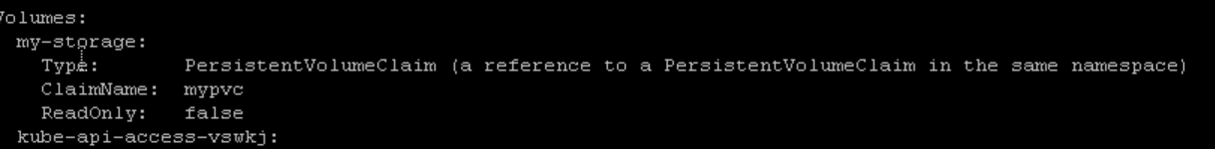

Connection Blw pv and pvc:





3.And tried to create a file in the path of the persistent volume mounted location, you can check in pv given /mnt/ and then it appears in the pod container that path stating that those two are connected:

Check the locations in the configuaration of pv and pod

Inside the container:



In pv location path:

As I runned the nginx the index.html Is inside the pod:

Cat the index.html inside the pod

